Recognized pattern: FakeDoc_variety1

The pattern has a form:

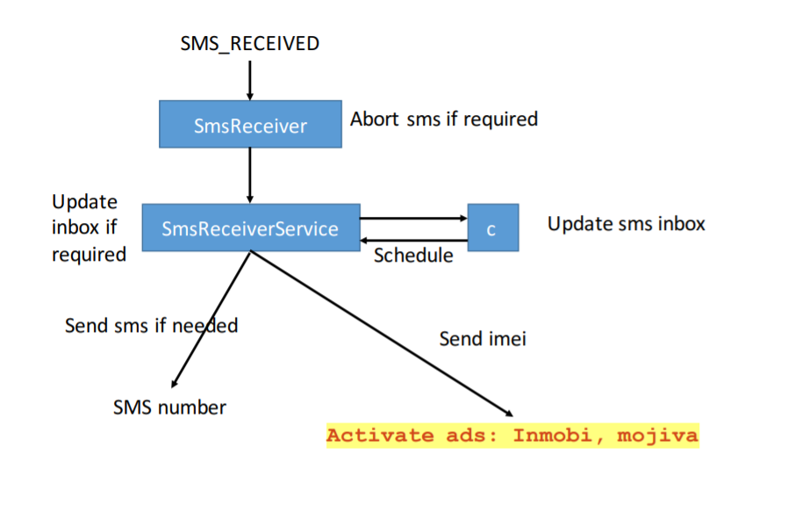

Name of Sample app: Battery SuperCharger

The name of this app: Domodroid

For functional modules (access to personal information such as telephone numbers):

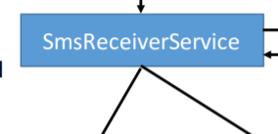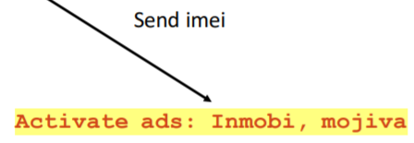

Corresponding to the key code in sample app:

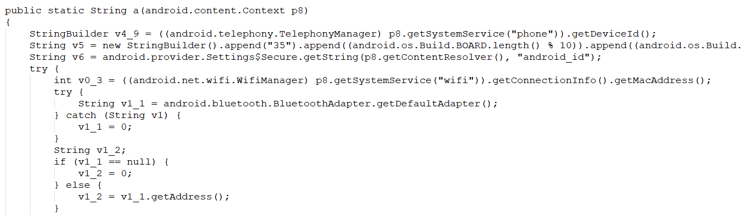

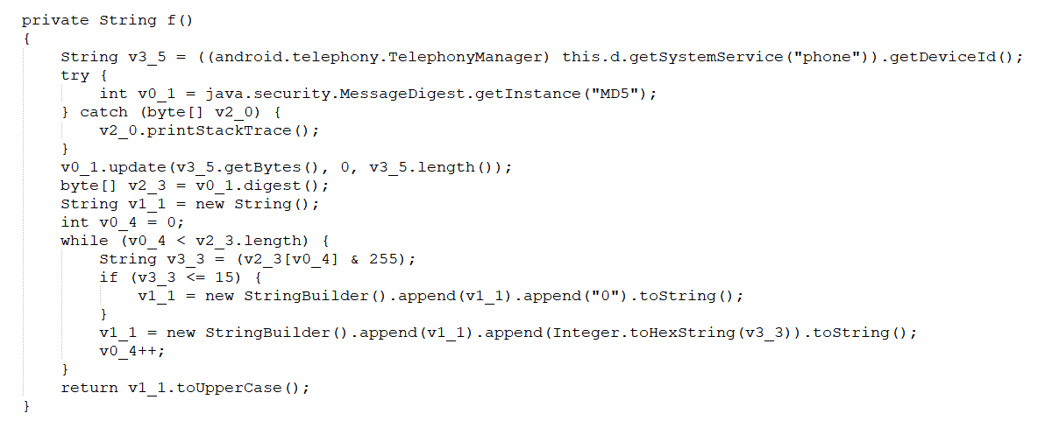

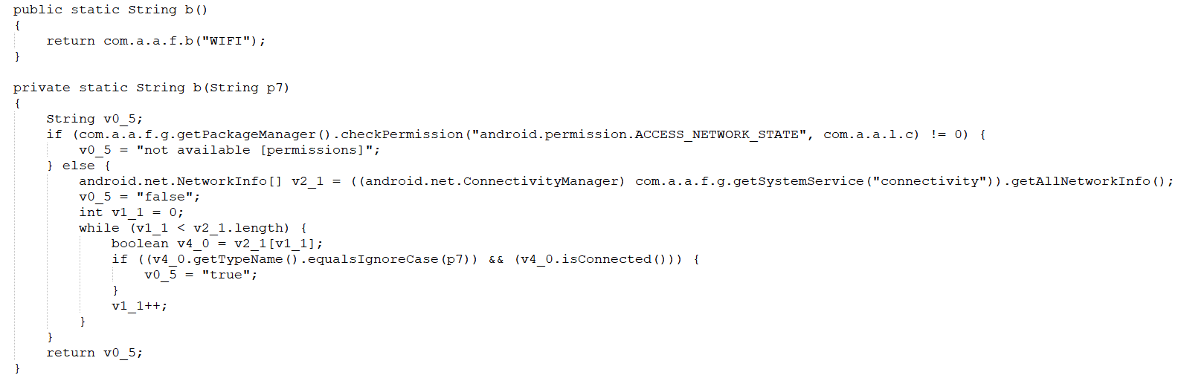

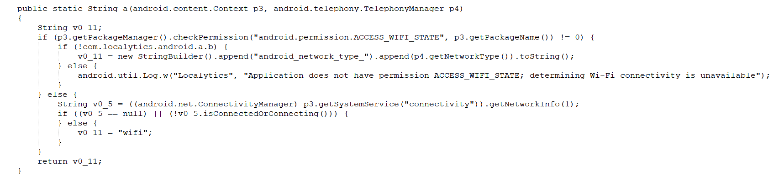

Corresponding to the key code in this app:

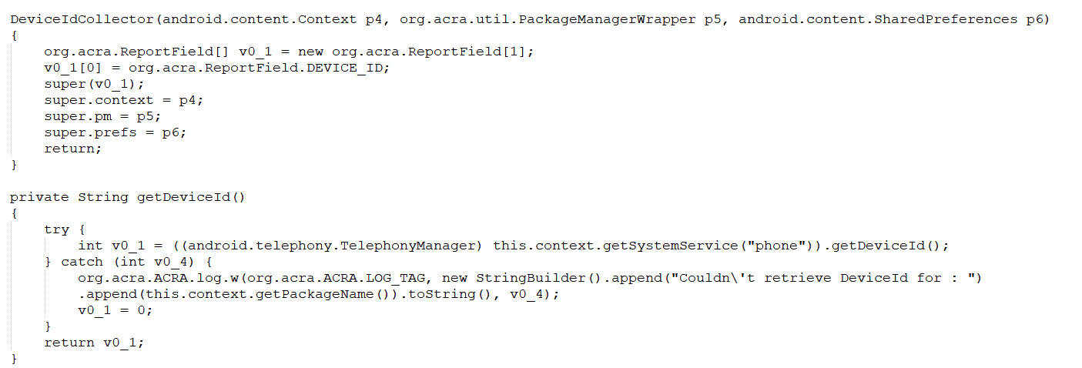

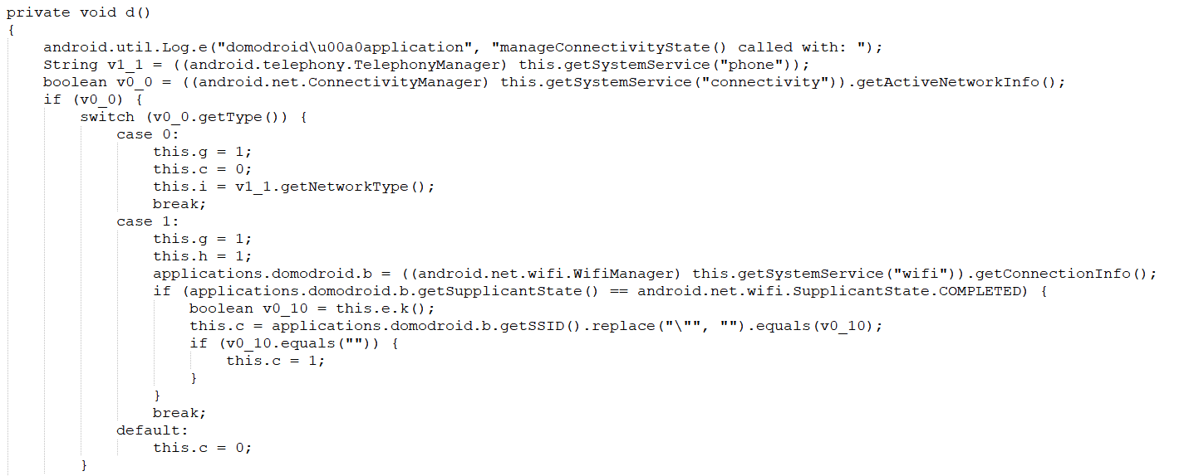

For functional modules:

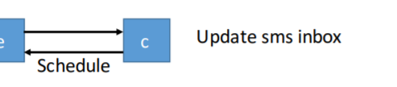

Corresponding to the key code in sample app:

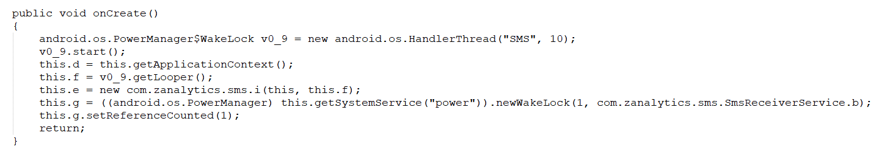

Corresponding to the key code in this app:

